Student Roll Number: 24K-0945
Student name: Syed Aazmir Hussain
Instructor: Mr Mubashir
Course: DLD Lab
Lab No: 4

Qs 1

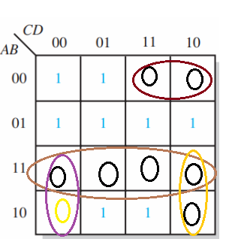

(A + B + C’) (A’ + B’) (A’ + C + D) (A’ + C’ + D)
= (A.A’ + A’B + A’C’ + B’A + B’B + B’C’) (A’ + C + D) (A’ + C’ + D)
= (A’B + A’C’ + B’C’ + B’A) (A’ + C + D) (A’ + C’ + D)
= (A’B + A’BC +A’BD + A’C’ + A’C’D + A’B’C’ + B’C’D + AB’C + AB’D) (A’ + C’ + D)

= A’B + A’BC + A’BD + A’C’ + A’C’D + A’B’C’ + A’B’C’D’ + A’BC’ + A’BC’D + A’C’ + A’C’D + A’B’C’ + B’C’D’ +AB’D + A’BD + A’BCD + A’BD + A’C’D + A’B’C’D + B’C’D + AB’CD + AB’D

= A′B + A′BC + A′BD + A′C′ + A′C′D + A′B′C′ + A′B′C′D′ + A′BC′ + A′BC′D + B′C′D′ + AB′D + A′BCD + A′C′D + A′B′C′D + B′C′D + AB′CD + AB′D
= A′B + A′C′ + A′B′C′ + B′C′D′ + B′C′D + AB′D + AB′CD + AB′D
= A’B + A’C’ + AB’D + B’ C’

2.
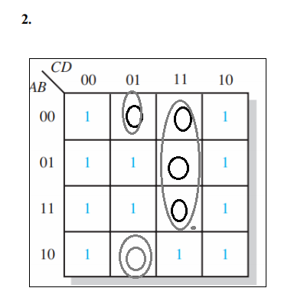

(C’ + D’) (B + C + D’)
= BC’ + C’D’ + BD’ + CD’ +D’
= BC’ + C’D’ + D’
= BC’ + D’

Qs 2

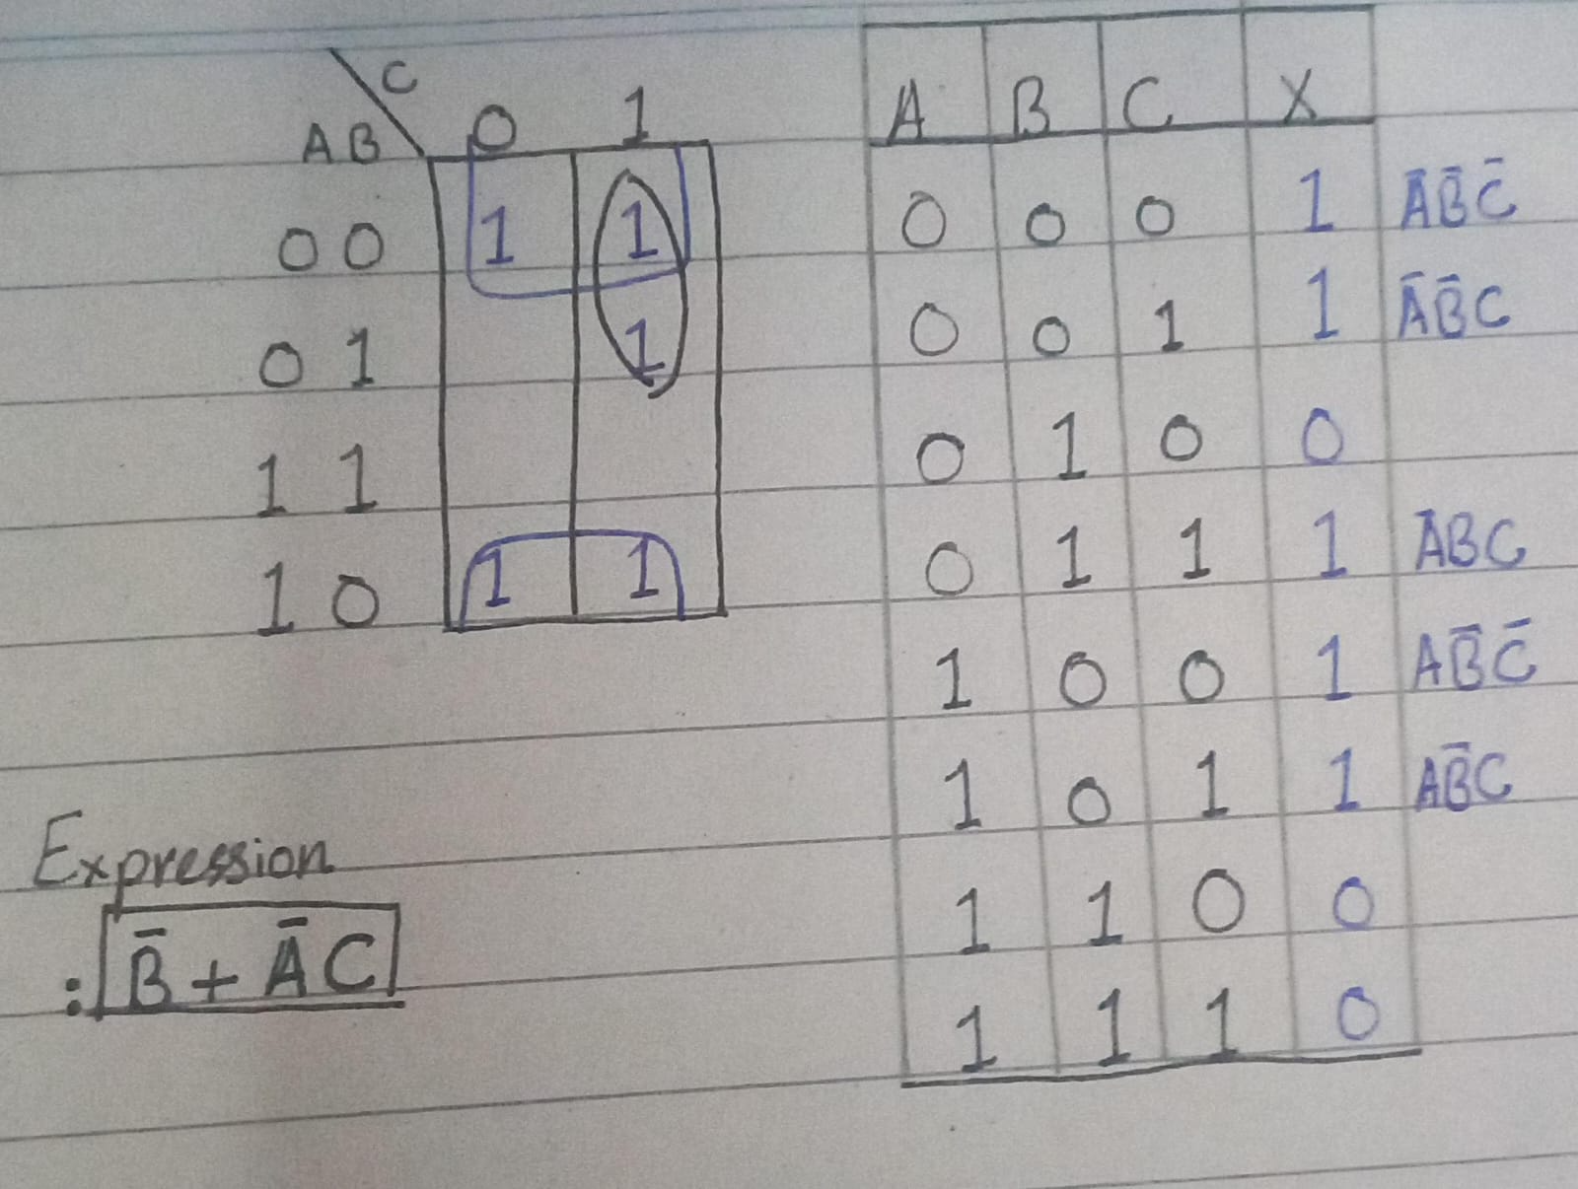
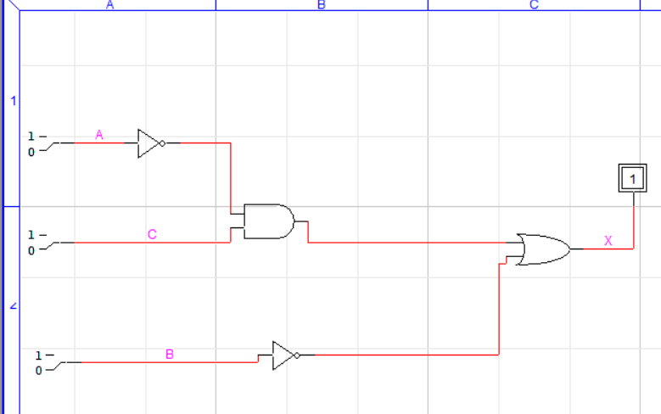

Qs 3

POS:

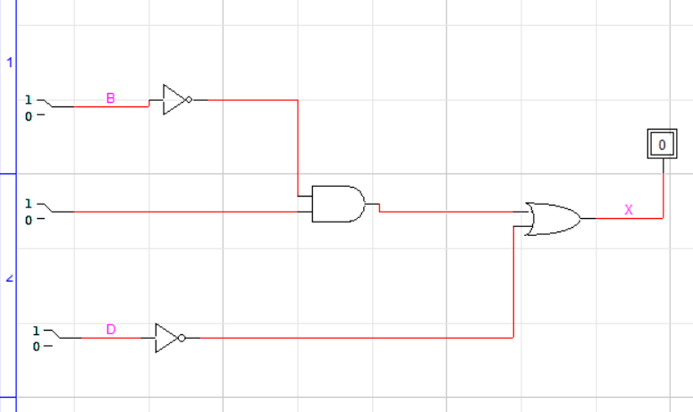

SOP:

